For the association rules, we use the package orange for running Apriori algorithm for the dataset in order to generate the frequency item.

First we generated the csv into a table, and from the chosen attributes from both dataset( “places”, “city”, ”incident_type”) we first build a dictionary and convert into numeric data and started to run for the algorithm. After that we convert the numeric data back into the original categorical data for reader to read easily.

We generate the top 5 Association Rules in both dataset.

The Montgomery Crime data the most frequently one is ‘2812’, ‘Street – In vehicle’, ‘Sliver Spring’ which 2812 represents “DRIVING UNDER THE INFLUENCE”. The support value for the association rule is 2723.

The outcome does not surprised us, because Sliver Spring, 2812 and Street – In vehicle they were already the highest frequent one from our previous statistic analytic. According to the rules, police officer can expect the crime is going to happen in those districts, and prepare the equipment that can fit to fight those particular crime.

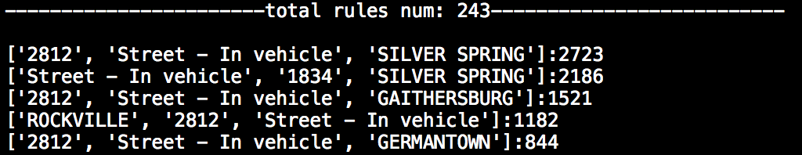

The Chicago Crime data the most frequently one is ‘25, ‘Theft’, ‘Sat’ which 25 represents “Community 25 “in Chicago which is Austin. The support value for the association rule 1124.

The outcome does not surprised us, because 25, Theft, Sat they were already the highest frequent one from our previous statistic analytic. From the top 5 association rules, we can increase the patrol frequency within those days in the communities.

